FPV Drone & Transmitter

***By Yaxin Lin***

# 

# 

## Showcase / Description of Finished Piece

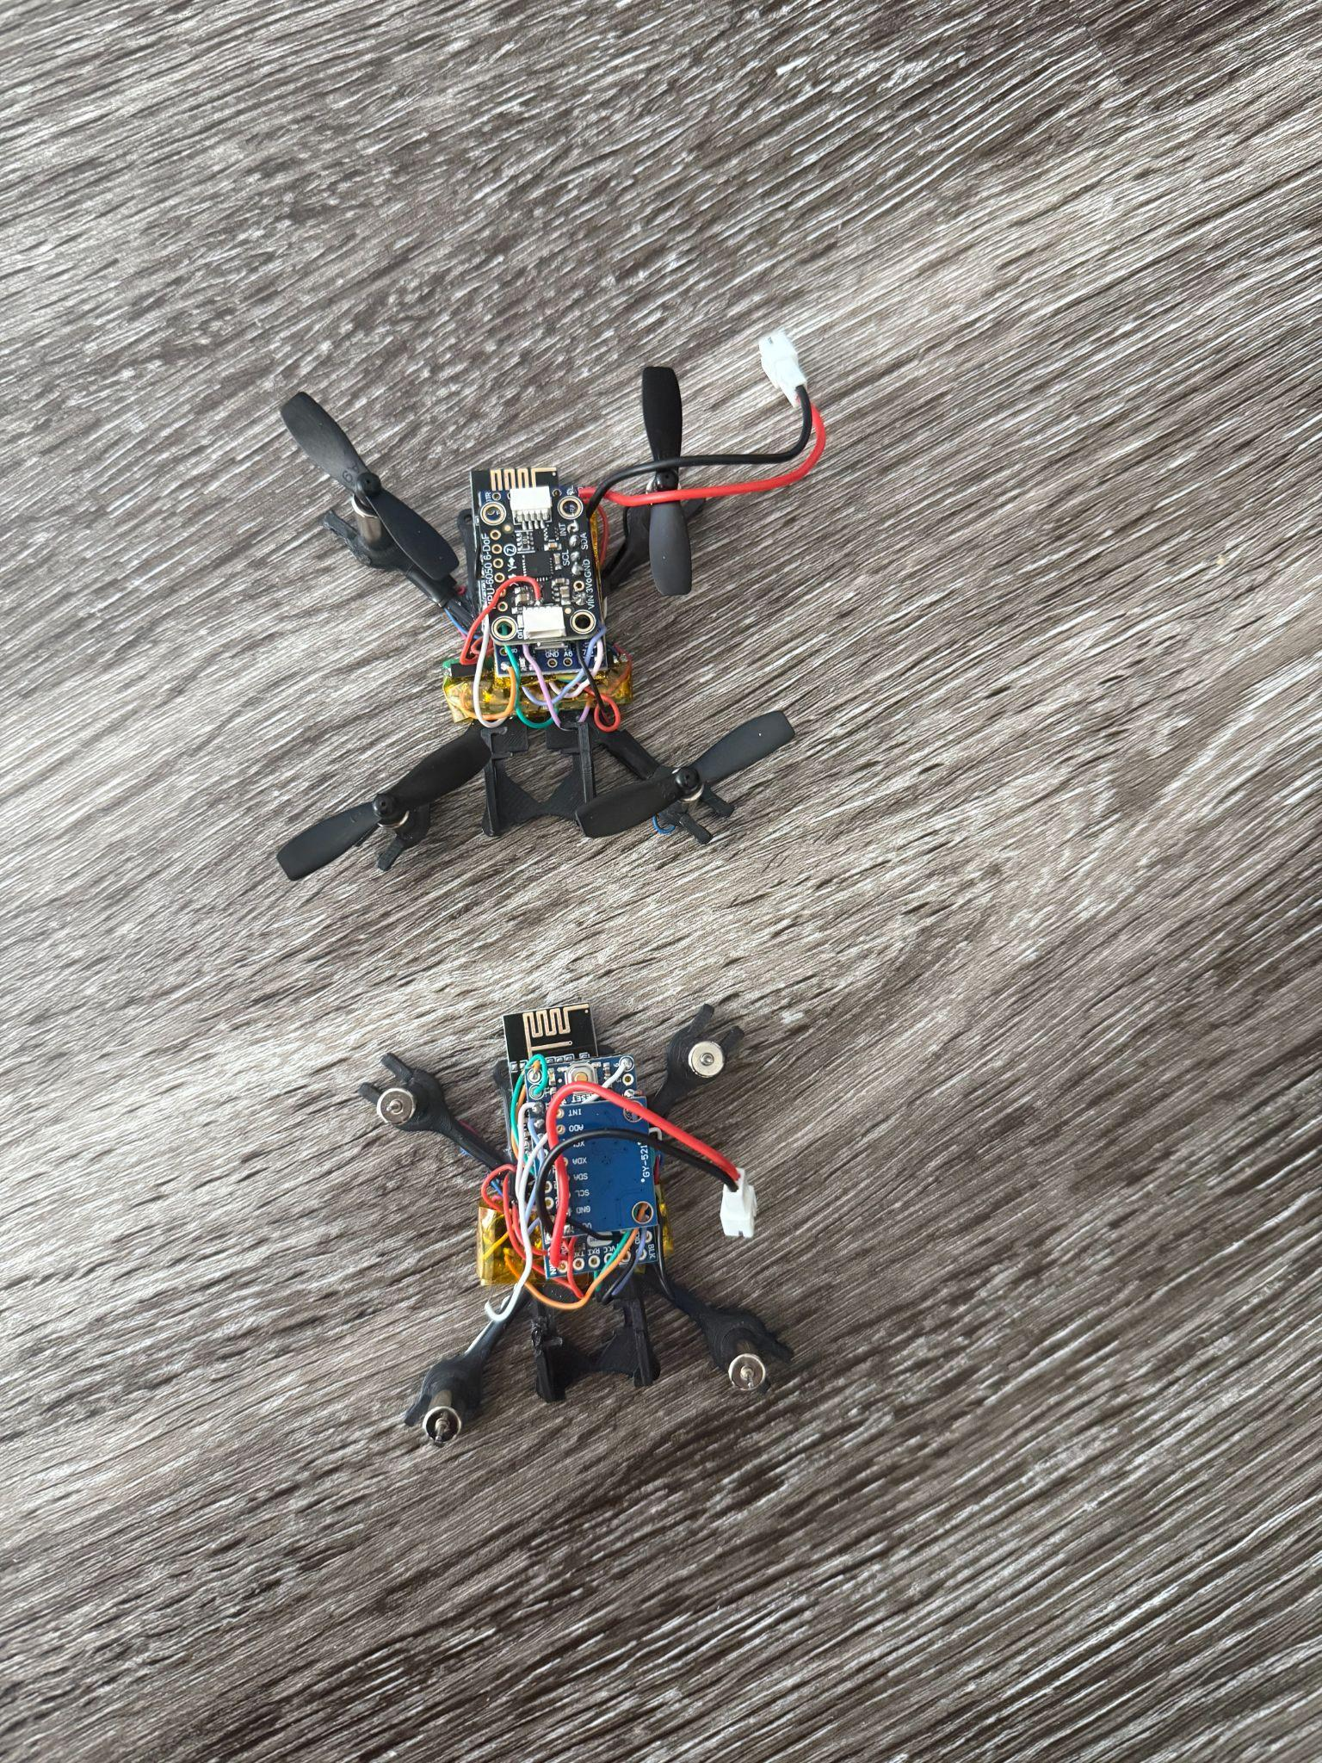

My finished piece is a 46-gram, palm-sized FPV quadcopter built around a 3.3 V Arduino Pro Mini, an nRF24L01 radio link, and a custom four-MOSFET brushed-motor driver。The project began as an attempt to produce an drone like DJI; along the way I learned surface-mount rework after a shorted Schottky diode went up in smoke, rebuilt the air-frame when 6 mm motors would not press-fit, and ultimately swapped my entire 5 V electronics stack for a 3.3 V ecosystem to solve upload failures and sensor-logic mismatches. Also I redesign the original model made by Max Imagination.

[Video Link](https://drive.google.com/file/d/1-S-QOWQWo8_faaF52qgOyunn5xN-1oHm/view?usp=sharing) (Drone)

[Video Link](https://drive.google.com/file/d/1Y1LL0UyLpyWvIrokkhaWHd6H4LkUbBXu/view?usp=sharing) (Transmitter)

Process

| <https://www.youtube.com/watch?v=Sa6EslOHsI0&t=559s>  <https://www.hackster.io/mertarduino/how-to-make-wireless-gesture-control-robotic-hand-cc7d07#code> | This is my inspiration. While I was trying to get some ideas and looking for the arduino youtube video, I found this instruction. Because I have loved playing with DJI drones since I was a child, I would like to try creating one on my own.  Then I had a new idea coming in my mind. When I read fiction, there are often plots about magic controlled by hand gestures. So I would like to try using the hand to control the drone instead of the normal controller.  This is the original model from the tutorial for the Drone.  Then I found the motor can’t be inserted in the hole and it is hard to use hot glue to make it stable.  This is my improved version, because I found it difficult to fix the motor in the original model. After the test, the hole can hold the motor without any glue.  Test print! |
| --- | --- |
| **Ideation/Design Process Box**  This part is the hardest thing and I had to try different solutions and try to fix the 3d print bug multiple times. | |

|  | This is the multiple small resistor, MOSFET, and the Schottky Diode. These things are very hard to solder when I’m first soldering.  There was a small incident at the beginning. During the test, the solder points on the back of the PCB board were connected together, causing a short circuit. When the short circuit occurred, a puff of smoke came out, and the Schottky Diode burned. I then replaced it and cleaned the solder points on the back that were connected together.  This is a picture when I measure the motor diameter. I want to make sure my model needs to hold the motor.  This is the picture of the redesign model.  Here I am connecting MPU6050 to Arduino pro mini.  The original project pairs a flex-sensor glove with an Arduino-Nano-based robotic hand. Five flex sensors stitched along the fingers form a voltage-divider array. A transmitting Nano samples the analog bends, packs them into an nRF24L01 data frame, and beams everything wirelessly. A second Nano receives the packet and steers five MG996R servos so that the 3-D-printed hand mimics the wearer’s finger angles in real time. The result is an inexpensive, fully wireless, 10-hour-build that demonstrates proportional control of five degrees of freedom with only off-the-shelf parts and minimal code.  I planned to adapt it. My initial idea was to reuse the glove as a transmitter for my micro-drone: Map each flex value to throttle, pitch, roll, and yaw. Keep the nRF24L01 RF layer exactly as in the Hackster code, only rewriting the packet structure to match MultiWii.  This would have let me fly the quad purely by finger gestures—no sticks, no gimbals, just a lightweight glove.  Prototype tests quickly revealed so show-stopper:Excessive Sensitivity. The flex elements respond instantly but take several hundred milliseconds to settle. Even after simple moving-average smoothing (8-sample window) the glove still produced erratic spikes.  Until those bugs are fixed I will revert to a conventional joystick radio for safety, but the glove remains a promising test-bed once its over-sensitivity is tamed. |
| --- | --- |
| **Prototyping/Building Process** | |

## 

## Conclusion / Reflection

My initial vision for this project was to create an intuitive, gesture-controlled FPV drone inspired by magical gestures often portrayed in fantasy fiction. Early enthusiasm met reality quickly, as I encountered multiple challenges, such as intricate SMD soldering mishaps to critical voltage compatibility issues. During the prototyping stage, I discovered that using a 5V Arduino Pro Mini prevented me from uploading the necessary MultiWii flight controller firmware, as the sensors and modules required a 3.3V logic level. This revelation required me to pivot, forcing a rebuild of the drone’s electronics around a 3.3V Pro Mini.

Despite these setbacks, the iterative process taught me invaluable lessons in troubleshooting, prototyping, and resilience. I am immensely grateful to Dr. Sudhu for his patient guidance and willingness to support me beyond regular office hours, particularly when technical roadblocks appeared insurmountable. His encouragement and expertise greatly enhanced both my technical skills and my confidence in overcoming complex challenges. I'm not afraid the failure right now.

The work is far from finished. Over the coming months I plan to keep refining the air-frame and fully dial-in MultiWii. At the same time I’ll re-open the question of hand control. If flex sensors remain too sensitive, I will prototype the alternative Shm suggested: a lightweight, upward-facing camera on the transmitter side that runs a tiny-ML model to recognize finger poses in real time.

## 

## Links

| Code | <https://github.com/yaxin-lin/Desinv_23_Project/tree/main/Final%20project>  [MultiWii_RF24](https://github.com/yaxin-lin/Desinv_23_Project/tree/main/Final%20project/MultiWii_RF24)(code from tutorial)  [Drone_s Transmitter](https://github.com/yaxin-lin/Desinv_23_Project/tree/main/Final%20project/Drone_s%20Transmitter)(code and case from tutorial)  [redesign_Dronemodel.stl](https://github.com/yaxin-lin/Desinv_23_Project/blob/main/Final%20project/redesign_Dronemodel.stl)(redesign model by myself) |
| --- | --- |
| Final video | <link> (a link where we’ll find your video file in the class Google Drive. make sure it’s accessible and not private! ) |

## 

## Sources

| Make a Tiny Arduino Drone with FPV Camera | <https://community.dfrobot.com/makelog-314251.html> |
| --- | --- |
| How to Make Wireless / Gesture Control Robotic Hand | <https://www.hackster.io/mertarduino/how-to-make-wireless-gesture-control-robotic-hand-cc7d07#code> |
| ChatGPT | <https://chatgpt.com/> |
|  |  |